**Monton, Sean Paul M.**

**BSCS 1-1**

**Computer Programming 1 – Activity 11 (String Manipulation)**

**Output**

**Part 1:**

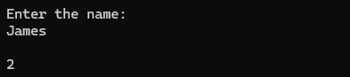

**Part 2:**

**Source Code**

**Part 1:**

#include <stdio.h>

#include <string.h>

int main() {

char name[50];

printf("Enter the name: \n");

scanf("%s", name);

printf("\n%d", strlen(name) % 2 == 0 ? 1 : 2);

return 0;

}

**Part 2:**

#include <stdio.h>

#include <string.h>

int main() {

int numOfWords;

printf("Enter the number of words: ");

scanf("%d", &numOfWords);

getchar();

char words[numOfWords][100];

int largest = 0;

printf("Enter the text: ");

for(int i = 0; i < numOfWords; i++) {

scanf("%s", words[i]);

if(strlen(words[i]) > largest) {

largest = strlen(words[i]);

}

}

printf("\nThe length of the largest word is: %d", largest);

return 0;

}